**IBM ASSIGNMENT- 1**

# TEAM ID : PNT2022TMID52179

# NAME: MALATHI. P

# ROLL NO: 963019106002

# Make a smart home with sensors using Arduino UNO

# LPG Gas leakage detector using arduino Components Required

### Arduino UNO

### MQ-6 gas sensor

### 16×2 LCD module

### 10K potentiometer

### Red and green LEDs

### 220 ohms resistors

### Jumper wires and a breadboard

### USB cable for uploading the code

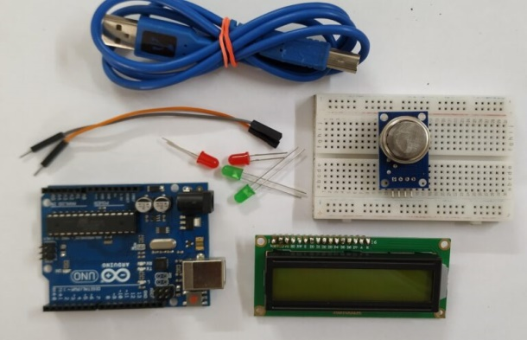

**CIRCUIT LAYOUT:**

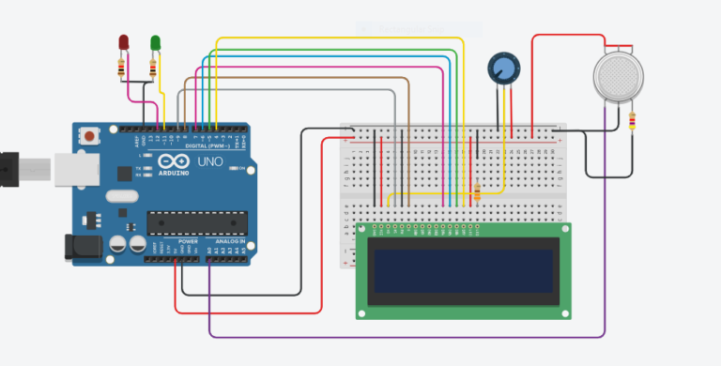

**CODE :**

**#include "LiquidCrystal.h"**

**LiquidCrystal lcd(9,8,7,6,5,4);**

**int GAS_VAL = 0;**

**void setup()**

**{**

**pinMode(A0, INPUT); // MQ-6 A0 Pin**

**Serial.begin(9600);**

**lcd.begin(16,2);**

**pinMode(11,OUTPUT); // LED Green**

**pinMode(12,OUTPUT); // LED Red**

**lcd.setCursor(0,0);**

**lcd.print(" GAS SENSOR ");**

**}**

**void loop()**

**{**

**GAS_VAL = analogRead(A0);**

**Serial.println(GAS_VAL);**

**if (GAS_VAL > 500)**

**{**

**lcd.setCursor(0,1);**

**lcd.print(" LPG Detected ");**

**digitalWrite(11,HIGH);**

**digitalWrite(12,LOW);**

**}**

**Else**

**{**

**lcd.setCursor(0,1);**

**lcd.print("LPG Not Detected ");**

**digitalWrite(11,LOW);**

**digitalWrite(12,HIGH);**

**}**

**delay(10);**

**}**

**Output:**

# 